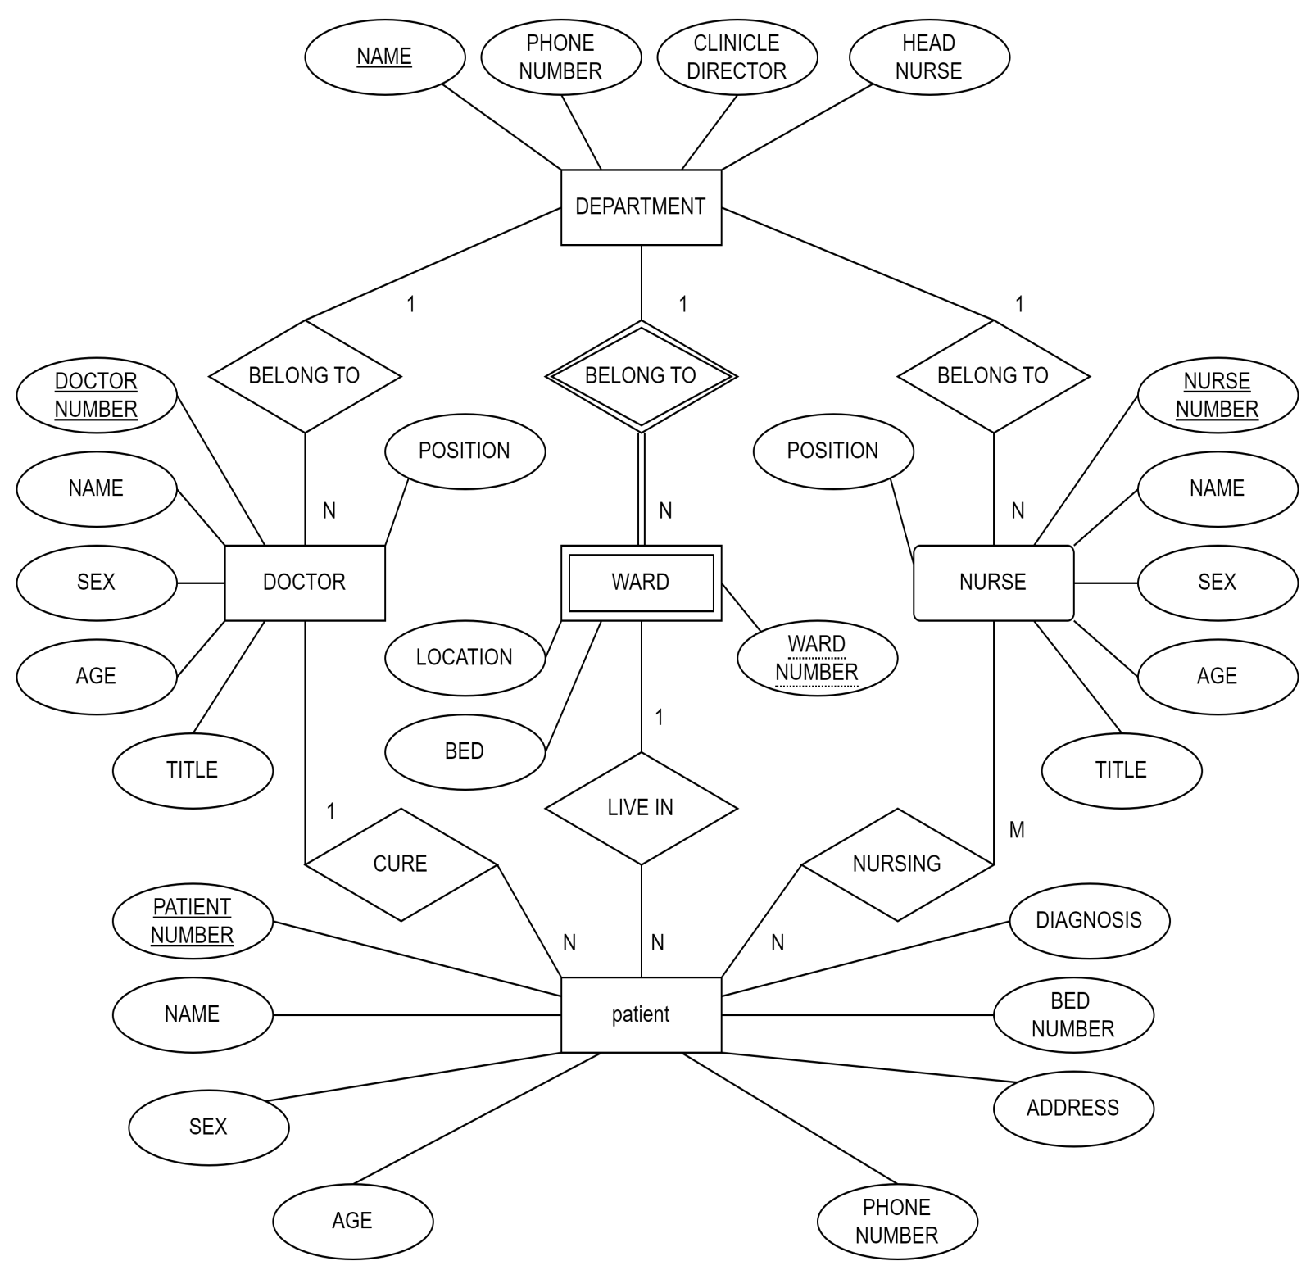

**Assumption:**

**Names of departments are unique.**

**Numbers of wards are not unique.**

**Each patient is managed and treated by only one doctor, managed by one nurse, but can be cared for by several nurses.**